CREDIT SALES (DEBTORS JOURNAL) AND CREDIT ALLOWANCES (DEBTORS ALLOWANCED JOURNAL)
Cash Sales
- Money is given immediately for items purchased. Items are immediately exchanged during cash. (This is a cash transaction).
Credit Sales
- Items received immediately but the money will be paid at a later stage with more interest.
- Businesses sell mainly on credit to increase their sales and cash flow in the business is improved
ACCOUNTING CONCEPTS
No. | Accounting Concepts | Definition/ Description/Examples
1 | Credit Sales | When goods are sold on credit with the aim of increasing clientele and turnover
2 | Debtors | Customers who owe money to the business
3 | Credit Agreements | Specifies the credit limit, payment terms and penalties
4 | Invoice | Document issued to customers when goods are sold for credit
5 | Credit Bureau | Private business which collects the credit records of customers
6 | Repayments | Money owed is paid back
7 | National Credit Act | Aims at preventing people from spending money they do not have.
8 | Creditworthiness | Having a good credit record and affordability
9 | Credit reference | Process conducted by businesses when a customer wants to buy goods on credit to make sure that they are trustworthy and can pay the debt.
10 | Term of Credit | The time or the period that the debtor must pay their account.

Credit-worthiness
- Before a business will grant a person to buy on credit, they first must see if the person is credit worthy – if the person is able to pay back its debts.
- To do this, they must look at a persons’ credit record – how did the person paid back previous debts.
- If the business is satisfied, the business and the person will go into an agreement

Such an agreement specifies the following:
- Credit limit – the maximum amount the debtor can owe on a specific date.
- Payments terms – how long can the debtor pays his/her account.
- Incentives or rewards – can give the debtor discount if he/she pays earlier.
- Penalties – charge the debtor interest for late payment on his/ her account
Recording of credit sales
1. Source document.
We have learnt from the accounting cycle that when a transaction takes place it must be recorded on a source document. The source document for credit sales is a credit invoice.
CREDIT INVOICE
- This is a source document which lists goods bought with prices charged and serves as proof that the transaction between a seller and buyer has taken place
INVOICE
NO : INV1234
TO: C. Roux 78 Howard avenue
112 Oak street Benoni
Northmead 1500
Date:12 September 2011
Ntuta Stores
Description | Unit Price | Amount  R
Chairs | R350, 00 | 2 800
tables | R1040, 00 | 3 120
cupboard | R1300, 00 | 1 300
Total |  |  |  | 7 220
Terms : 30 days, 5% discount
Special instructions: none E&OE

What is a debtor?
- A debtor is a Current Asset He owes the enterprise money
- The business sell goods/services to him on credit
- The enterprise issues the Debtor with an invoice
- The SOURCE DOCUMENT is the DUPLICATE INVOICE (This is a duplicate invoice because the customer will always get the original invoice and the business completes the journal from the duplicate invoice, therefor it is a duplicate invoice for the business and an original invoice for the customer.)
- These transactions are recorded in the Debtors Journal (DJ)
- When the Debtor settles his account or makes a part payment, the enterprise issues the debtor with a receipt (original).
- The source document once payment is received, is the duplicate receipt
- This receipt of money is recorded in the Cash Receipts Journal (CRJ)

The Debtors Journal (DJ)
- All transactions during which an enterprise SELLS ON CREDIT will be entered in the first book of entry the debtor’s journal.
- So all goods sold on credit will be recorded in the debtors journal.
- When an enterprise issues invoices to various customers the invoices are numbered chronologically and it is these numbers that you use for recording purposes in the Journal. (The invoice will be in chronological order meaning if we start with invoice number 501 the next invoice will be 502,503,504 etc
Format of the Debtors Journal
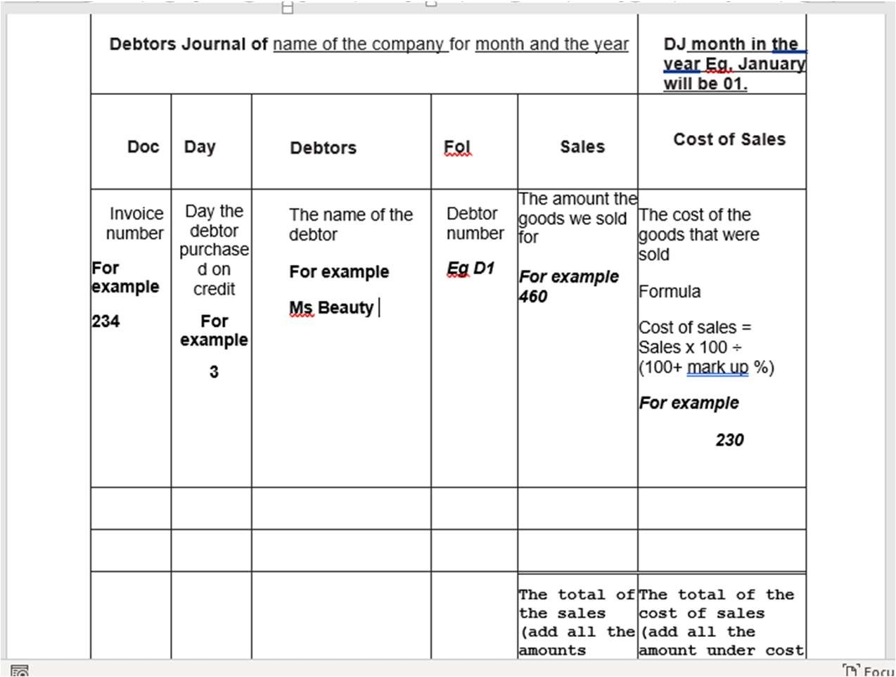

DEBTORS ALLOWANCES:
- In the debtors' allowance journal we record transactions where debtors send goods back.
- Debtors send goods back for the following reasons:
Wrong color,
wrong size,
The product is broken,
They are not satisfied with the product Or if a product is overpriced an allowance will be given. (The amount which is over charged with will be written back on the debtors account. For example if you paid R300 for a t-shirt and it should only cost R200, the R100 that was over charged will be credited to your account. You will now be in credit with the store. )

- When a debtor returns goods, we issue a CREDIT NOTE. So the source document for the DAJ is a DUPLICATE CREDIT NOTE. (Remember the customer will always get the original invoice and the business will use the duplicate to complete the journal)
- It is a credit note because the customer’s account must now be credited (decreased with that amount)
Format of the debtors allowances journal:
C/N no | day | Debtor | Fol | Debtors allowances | Cost of sales

Transactions to record for March 2018
- Sold merchandise on credit to B.Blue for R460 (cost priceR345) as per invoice no BQ12
doc | day | Debtor | Fol | sales | Cost of sales
BQ12 | O1 | B. Blue |  | 460 | 345
- B Blue complained about the quality of goods supplied to him on the 1st. A credit note (c12) for R80 (cost price R60) was issued to him for the goods returned.
C/N no | day | Debtor | Fol | Debtors allowances | Cost of sales
C12 | 2 | B.Blue |  | 80 | 60

